Title of the Seminar : ……………………………………………………………………………………………………………
The Presenter : …………………………………………………………………………………………………………………………..
Please complete the following evaluation for the academic seminar you attended. Your feedback will help us evaluate the effectiveness of this seminar and allow us to make improvements .
Evaluation Factor 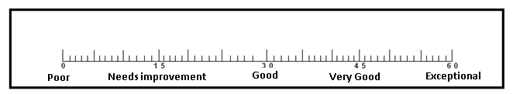 | Poor | Needs Improvement | Good | Very Good | Exceptional
Content Criteria
The content was helpful.
The content was understandable .
Scientific Accuracy of the content
Presenter-Related Criteria
Presenter’s knowledge of the subject
The presenter Was clearly spoken, loud enough and well-paced to allow the whole audience to hear
body language and eye contact of the presenter were purposeful
The presenter was able to respond to the audience questions
Overall Criteria
Creativity
Originality
The quality of the slides
overall rating of this seminar
TOTAL

What were the most useful aspects of the seminar?
……………………………………………………………………………………………………………………………………………………………..
What changes should be made to enhance/improve this seminar?
………………………………………………………………………………………………………………………………………………………………
What additional information would you like to hear about?
………………………………………………………………………………………………………………………………………………………………
Additional comments:
……………………………………………………………………………………………………………………………………………………………
Thank you

